Order Of Service

Singing: Psalm 16—CW page 68

Reading: Psalm 119:89-96

Opening Hymn: TLH 1

Reading: Hebrews 6:1-8

Request Hymn: CW Supplement 754

Reading: Luke 12:22-31

Sermon Hymn: TLH 448

Sermon Text: Hebrews 13:18-19

A Good Conscience

Prayer

The Apostles’ Creed, TLH page 12

Holy Communion

The Lord's Prayer

The Blessing

Closing Hymn: TLH 47

* * * * * * * * * * *

Bible Study: Lambs: Luke 15:3-7; You Are Important
Sheep: Proverbs 1:24-27; Your Choice
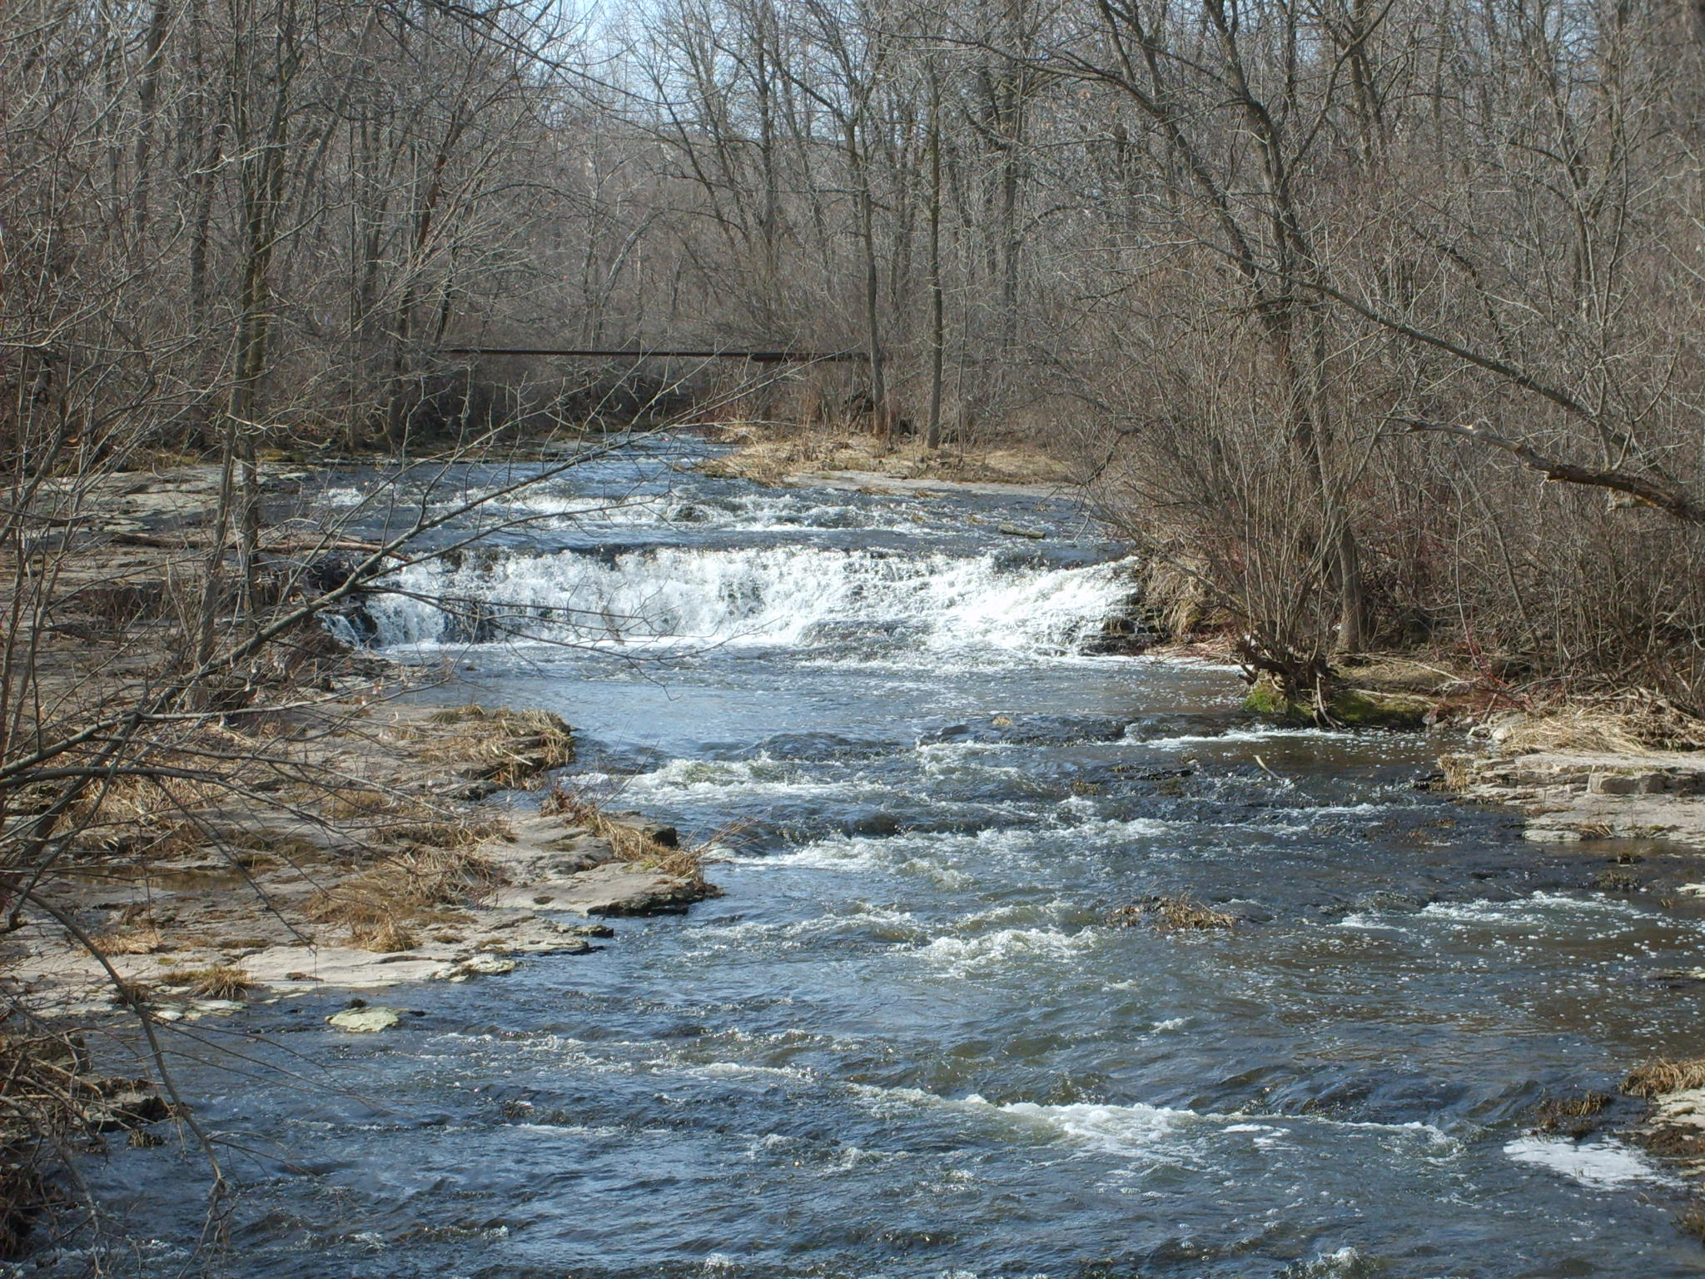

Spring on Sauk Creek

Water
Of
Life

12 April 2015

W A T E R O F L I F E

Independent Christian Church—Conservative Lutheran Doctrine

Worship Service: 9:30 a.m. Bible Study: 10:45 a.m.

Larry Cooper, Pastor E-Mail address:
111 N. Ridge Road lcooper@wateroflife.cc
Coon Valley, WI 54623 Web Site:
Phone: (608) 452-2105 www.wateroflife.cc

* * * * * * * * * * * * * * * * * * * * * * * * * * *

Sermon Text: Hebrews 13:18-19

A Good Conscience

* * * * * * * * * * * * * * * * * * * * * * * * * * *

18: Pray for us: for we trust we have a good conscience, in all things willing to live honestly.
19: But I beseech you the rather to do this, that I may be restored to you the sooner.

Some thoughts on prayer:

Prayer

"I will therefore that men pray everywhere, lifting up
holy hands, without wrath and doubting."
(1 Timothy 2:8)

You can pray for any need - for lengthened life, as Hezekiah did;
- For help, as Daniel did;
- For mercy, as David did;
- For rain, as Elijah did;
- For a son, as Hannah did;
- For grace, as Paul did.

You can pray, too, anywhere - In the deep, like Jonah;
- On the sea or housetop, like Peter;
- On your bed, like Hezekiah;
- In the mountain, like Jesus;
- In the wilderness, like Hagar;
- In the street, like Jairus;
- In a cave, like David;
- On the cross, like the dying thief.

You can pray, too, anyhow - Short, as Peter and the Publican did;
- Long, like Moses at the consecration of the Tabernacle,
- Or Solomon at the dedication of the temple.

You can pray in your secret thoughts, as Nehemiah did before Darius;
- Or aloud, as did the Syro-Phoenician woman;
- In tears, as Magdalene did;
- In groans or songs, as David did.

You can pray any time - In the morning, as David did;
- At noon, as Daniel did;
- At midnight, as Silas did;
- In childhood, as Samuel did;
- In youth, as Timothy did;
- In manhood, as the Centurion did;
- In age, as Simeon did;
-In sickness, as Job did;
- Or in death, as did Jacob and the dying Christ.

